WakeUp Service – Install and Config

# Installation of the App

## Adding the WakeUp-App

Download and unzip the app. There should be three files for the app to install correctly:

* httpfiles.zip
* WakeUp
* WakeUp.png

Open the ‘AP Manager’:

* Check the ‘Menu/Settings/General/Enable developer mode’-checkbox.

By default this is not ticked, but this must be enabled to install apps from outside a store and will show the needed menu-option ‘Menu/App Upload’.

* ‘Menu/App Upload’:
  + App ID: ‘WakeUp’
  + Title: ‘WakeUp’
  + Binary file -> Choose file: select the ‘WakeUp’-file
  + + Add files: select ‘httpfiles.zip’ and ‘WakeUp.png’

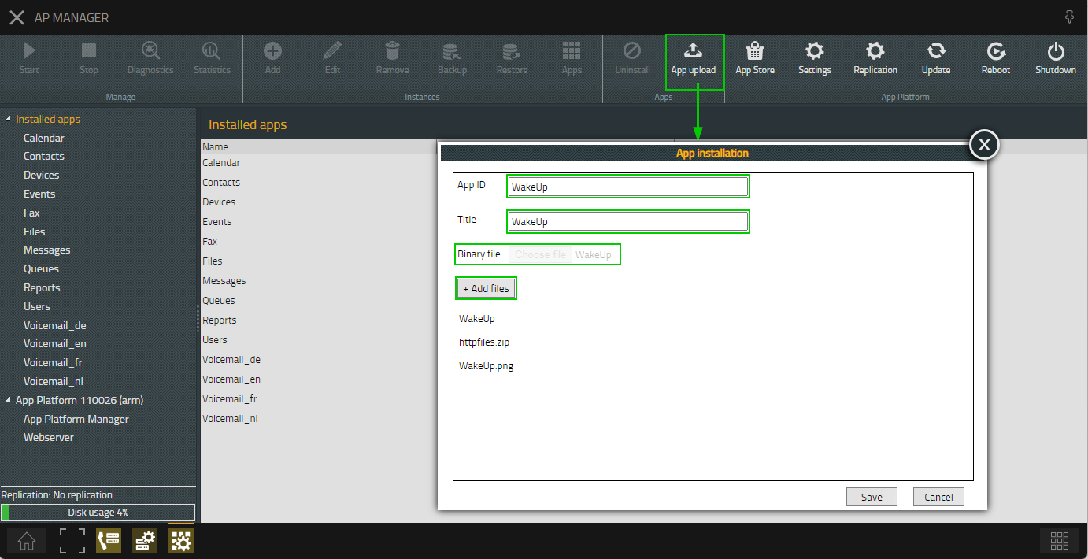

* + Click ‘Save’
* Select the ‘WakeUp’-app in the left menu + ‘Menu/+Add’:
  + Name: ‘WakeUp’
  + Domain: ‘voipserver.online’ // change it by the correct domain
  + Password: ‘pwd’ // change it by the Admin-pwd
  + Database password: ‘pwd’ // change it by a good strong password  
    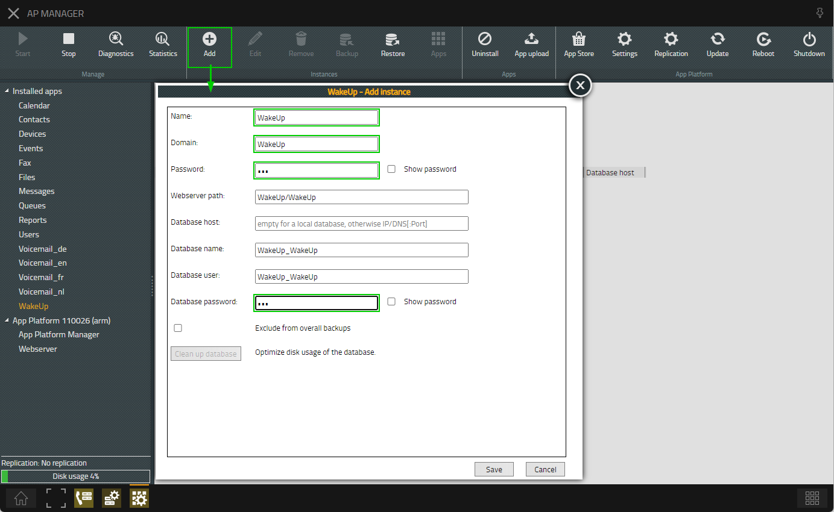
  + Click ‘Save’
* Select the created ‘WakeUp’-instance + ‘Menu/Diagnostics’:
  + Tick ‘App’
  + Tick ‘Database’
  + Tick ‘App WebSocket’  
    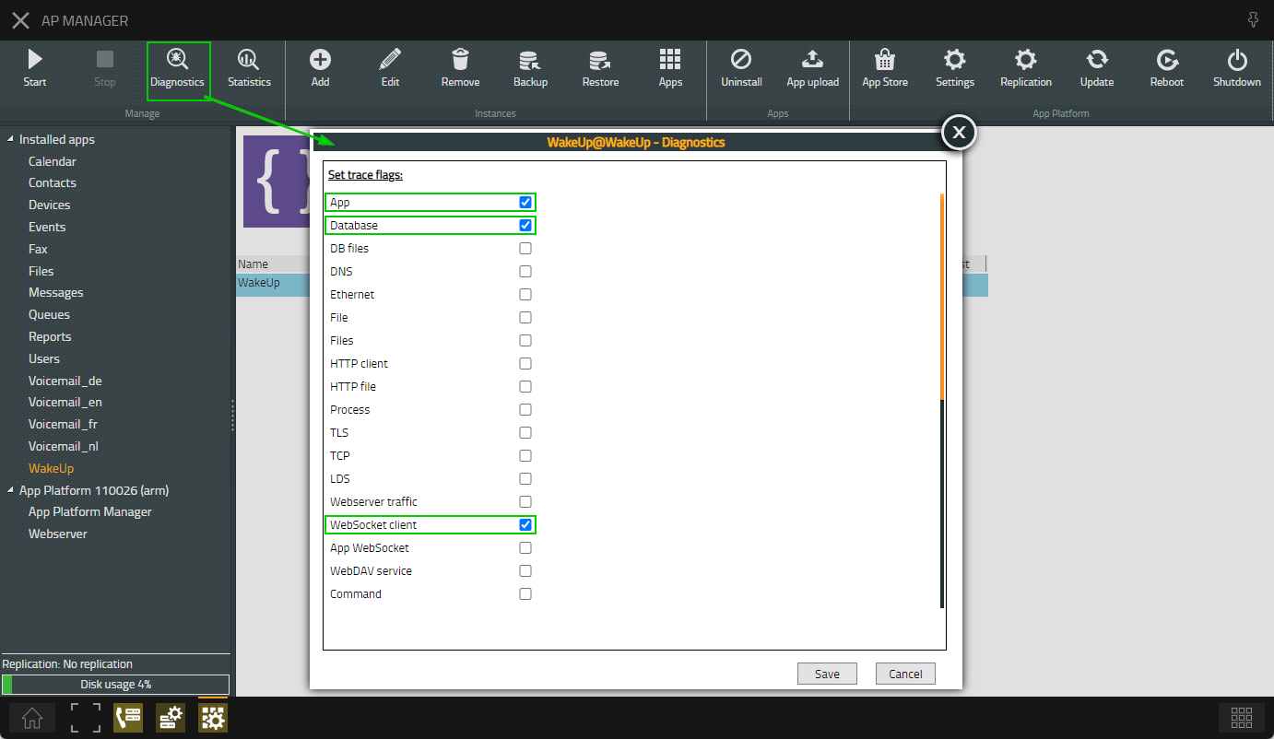
  + Click ‘Save’
* Click on ‘Menu/Start’

## Adding the App-objects

* Open the ‘PBX Manager’
  + Select the ‘AP WakeUp’
  + Click on ‘+ Add app’  
    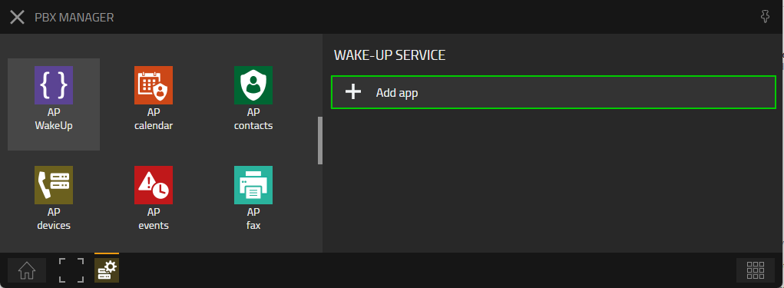
  + Click on ‘WakeUp Service’:  
    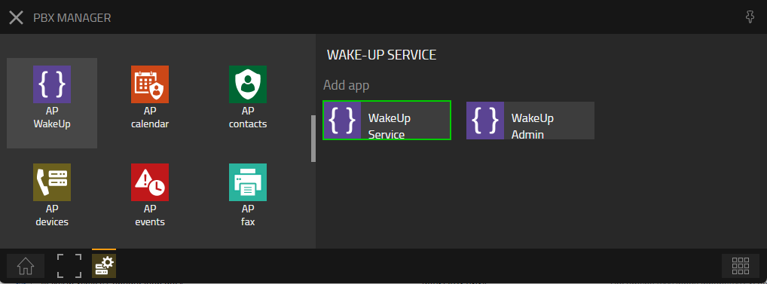
  + Enter the following data:
    - Name: ‘WakeUp Service’
    - SIP: ‘wake.up.service’

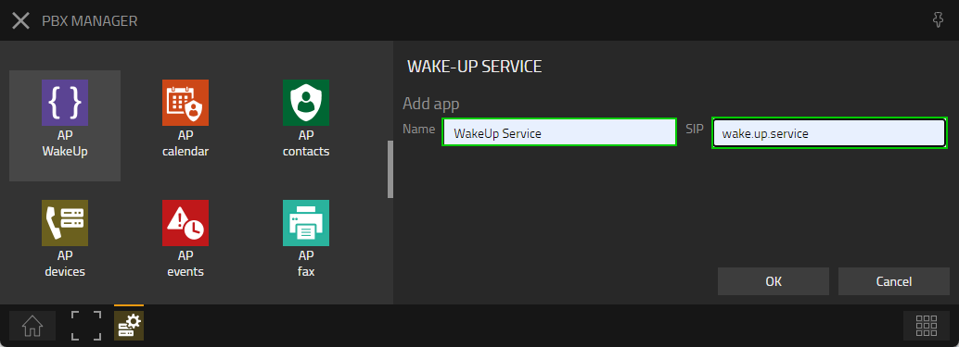

* + Click on ‘OK’
  + Click on ‘+ Add app’ once more  
    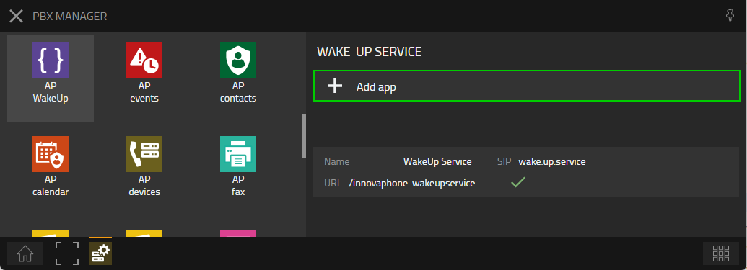
  + Click on ‘WakeUp Admin’:  
    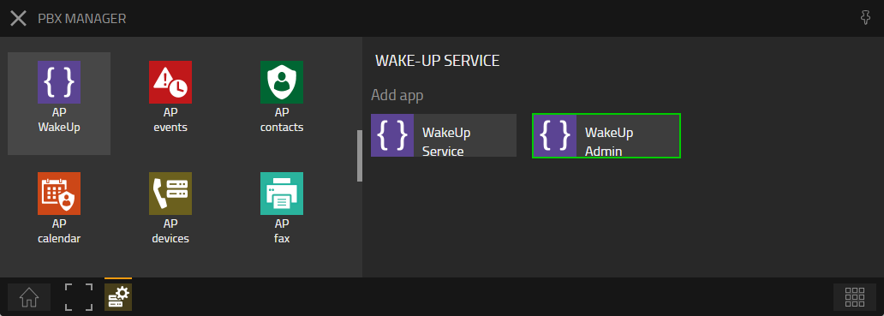
  + Enter the following data:
    - Name: ‘WakeUp Admin
    - SIP: ‘wake.up.admin’

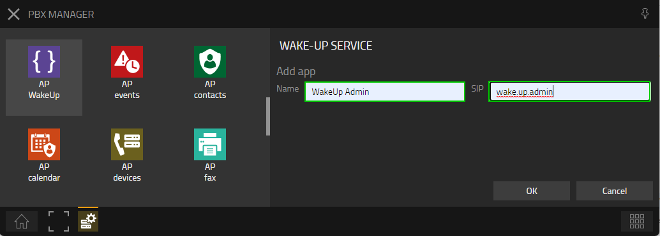

* + Click on ‘OK’

Both app should show a connected green ‘V’:  
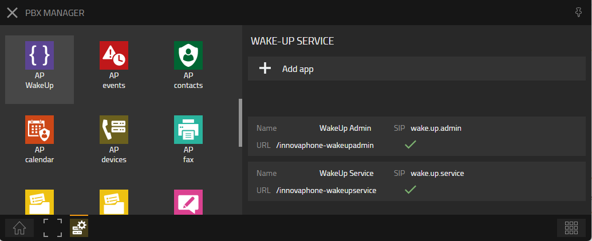

## Granting the right to open the WakeUp Admin

* Open the ‘PBX Manager-Templates’-plug
* Select the Template for the Administrators:  
  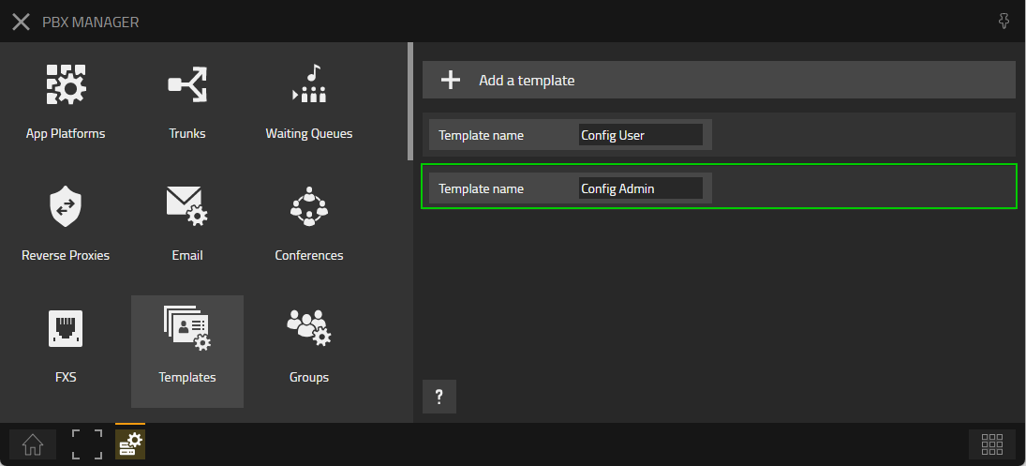
* Open the ‘Apps’-section and add/tick the ‘WakeUp Admin’-app to this template:  
  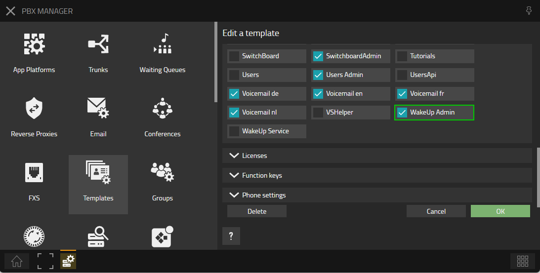
* Click ‘OK’

# Adding the WQ for the WakeUp Message

Add a Waiting Queue. This can be done via the Advance UI of the PBX or via the ‘PBX Manager’-‘Waiting Queues’-plugin. Make sure that the Waiting Queue plays directly a message…

* PBX Manager/Waiting Queues/+Add a waiting queue:  
  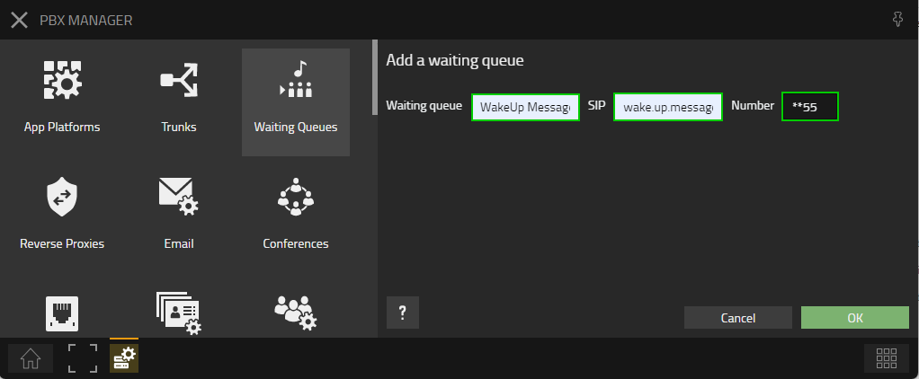
* PBX Manager/Waiting Queues/WakeUp Message/Announcements -> Select the Announcement:  
  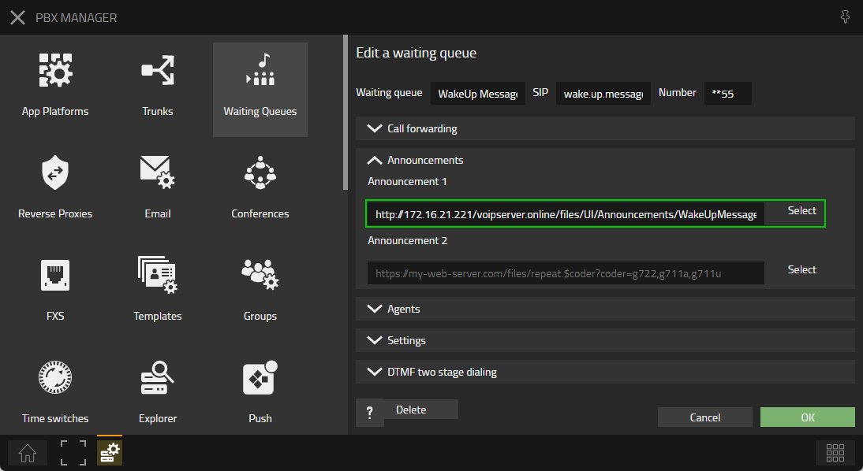
* PBX Manager/Waiting Queues/WakeUp Message/Settings -> Time to announcement(s) = 0:  
  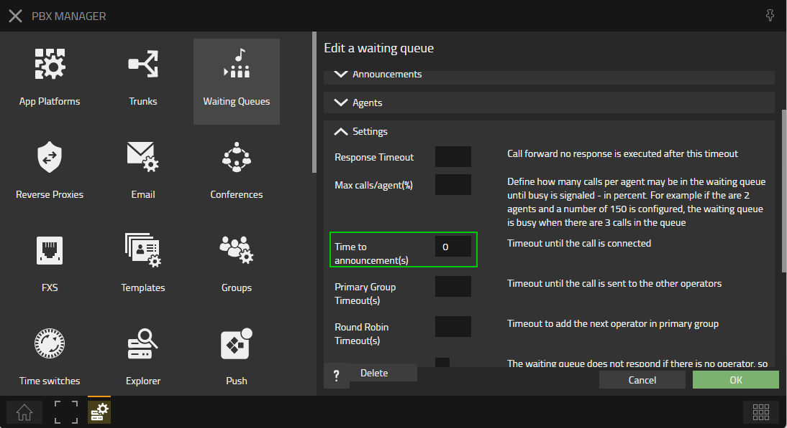

# Configuration of the app

* Open the ‘WakeUp Admin’-app (the user must have the Admin-template assigned) and configure it correctly:
  + PBX -> Master PBX: must be the name of the PBX (Advanced UI of the PBX -> PBX/Config/General/PBX Name.
  + Script Defaults -> Source Name: SIP-name of the Waiting Queue created earlier
  + Script Defaults -> Source Number: Number of the Waiting Queue created earlier
  + Script Defaults -> Retries (#): the number of retries
  + Script Defaults -> Timeout (s)
  + URL: copy the URL

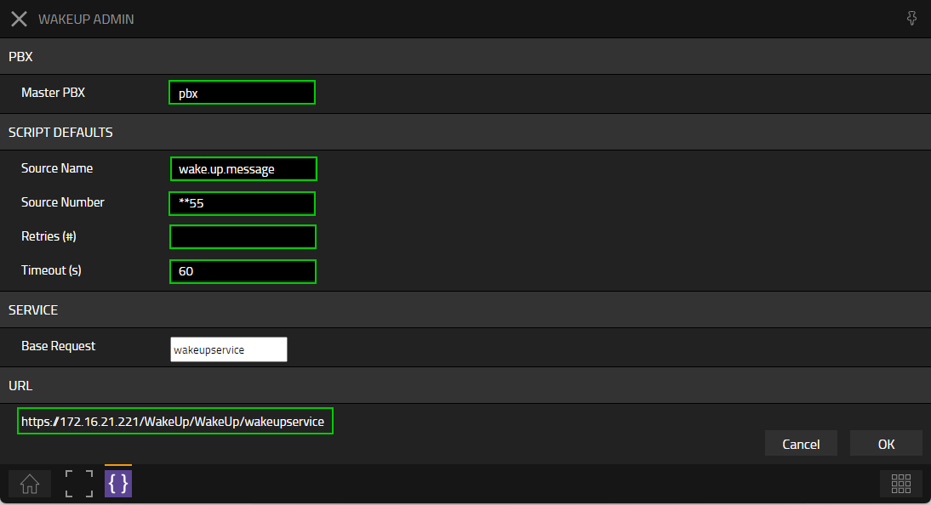

Please restart the App after changing the ‘PBX -> Master PBX’.

# WakeUp Voicemail-script

## Adjust the voicemail-script

Unzip ‘WakeUpScript.zip‘ and open ‘wakeup.xml’.

Change the value of ‘$serviceurl’ to the URL found in the previous log. End with a ‘/’!  
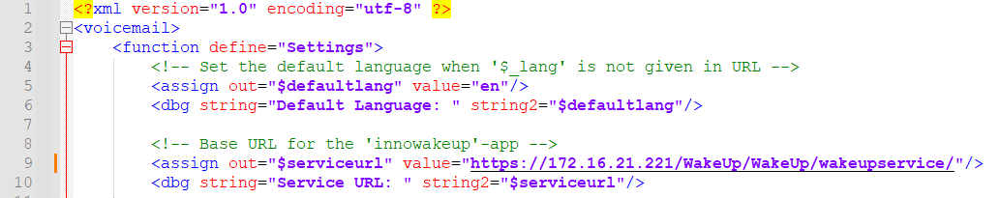

## Upload the scripts

Open the Files-app

* Add the (adjusted) files from the ‘WakeUpScript.zip’  
  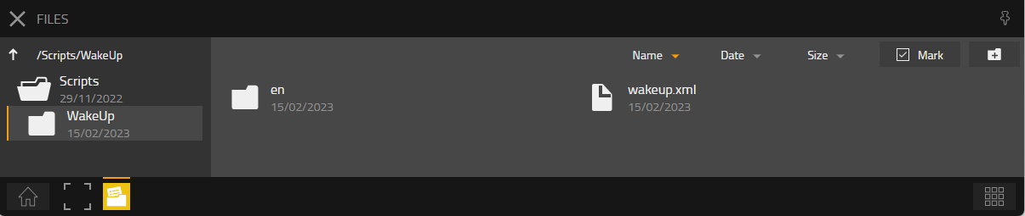
* Share the ‘WakeUp’-folder with user and password (‘wakeup’/’wakeup’)  
  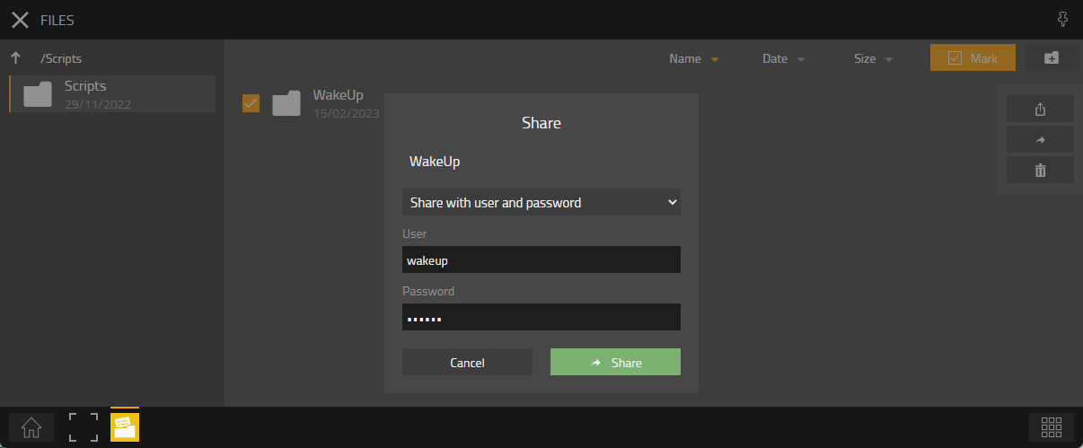
* Open the folder and click on the ‘i’ to obtain the correct URL  
  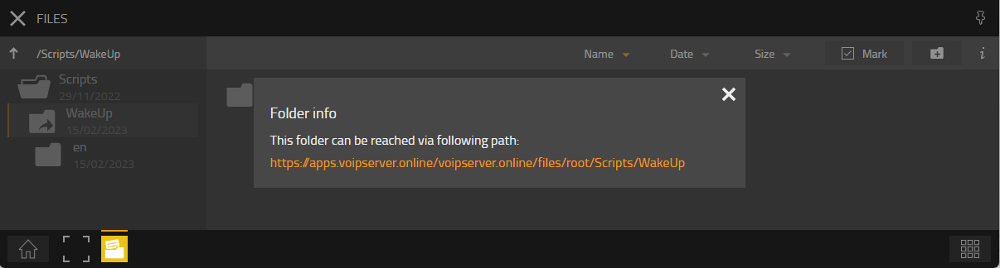
* Copy this URL as we will need it later:  
  <https://apps.voipserver.online/voipserver.online/files/root/Scripts/WakeUp>

# Create Voicemail-object

Open the Advance UI of the PBX and add a new Voicemail-object:

* Hide from LDAP: ticked
* Long name: ‘WakeUp Script’
* Name: ‘wake.up.script’
* Number: ‘55’
* Critical: ticked  
    
  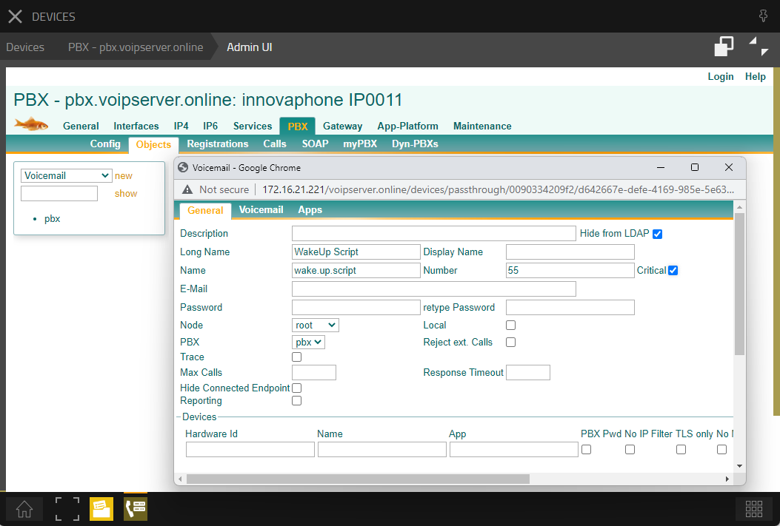
* Script URL: ‘<https://apps.voipserver.online/voipserver.online/files/root/Scripts/WakeUp>/wakeup.xml’
* User: ‘wakeup’
* Password: ‘wakeup’  
    
  